BioStat Explorer
A quick guide for the lab — loading data, filtering, plotting, and running stats

What this tool does
BioStat Explorer is a desktop app for exploring fluorescence/OD-type lab data: load spreadsheets or plate-reader exports, filter down to the samples you care about, plot them (bar, line, box, violin...), and run the right statistical test automatically — including comparisons against a chosen reference group (e.g. wild-type).

Getting it running
1. Open Terminal and go to the BioStatExplorer folder.
2. First time only — install the required packages:
pip install PySide6 matplotlib seaborn pandas scipy statsmodels openpyxl reportlab
3. Run the app:
python run.py
Note: If you get a permissions error opening the file, the folder likely still has macOS's download-quarantine flag on it. Run xattr -dr com.apple.quarantine on the folder once and try again.

Packaging it as a standalone app (no Terminal needed)
If you'd rather double-click an icon than open Terminal each time, you can package the app once into a standalone program using PyInstaller. This is a one-time (or occasional) setup step done in Terminal — after that, whoever has the packaged file just double-clicks it. The overall process is the same on every operating system:
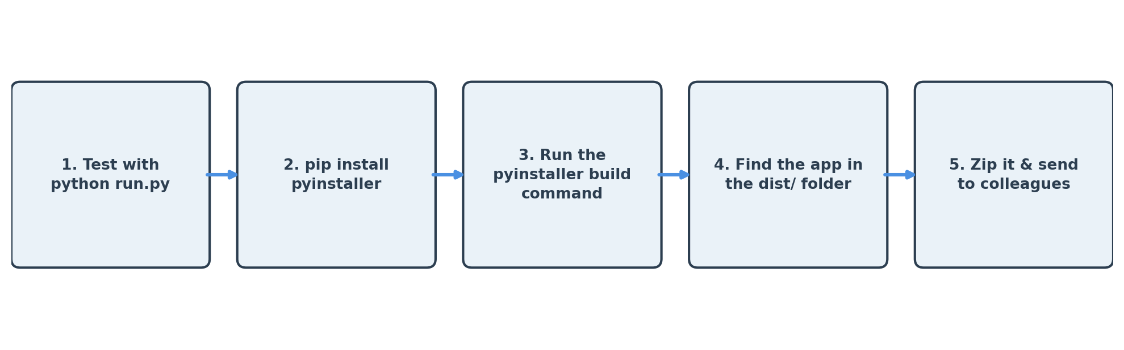

macOS
1. Open Terminal and go to the BioStatExplorer folder. If the path has spaces (e.g. "Python code for graphs"), wrap the whole path in quotes or cd won't work:
cd "/Users/you/Desktop/Python code for graphs/BioStatExplorer"
2. Make sure every package the app needs is actually installed in the conda environment you're using — this is the single most common cause of a build that runs but then won't open ("No module named ..." errors):
pip install pandas PySide6 matplotlib seaborn scipy statsmodels openpyxl reportlab pyinstaller
3. Build it:
pyinstaller --windowed --name "BioStatExplorer" --add-data "src:src" --collect-all matplotlib --collect-all seaborn --collect-all reportlab --collect-all pandas --collect-all scipy --collect-all openpyxl --collect-all statsmodels --collect-all PySide6 run.py
4. BioStatExplorer.app appears inside the new dist folder. Drag it to Applications, or zip it to send to colleagues:
cd dist && zip -r BioStatExplorer.zip BioStatExplorer.app
Note: Since the app is unsigned, the first launch on any Mac (including yours) will be blocked as "unidentified developer." Right-click the app and choose Open once — this is a one-time step per computer. A build made on an Apple Silicon Mac (M1/M2/M3/M4) will only run on Apple Silicon Macs; an Intel Mac needs its own build made on Intel hardware (or a universal2 build, which is more involved to set up).

Windows
PyInstaller doesn't cross-compile — a Windows .exe has to be built on an actual Windows machine (a colleague's PC, or a Windows VM), with Python and the app's packages installed there. In Command Prompt or PowerShell, from inside the BioStatExplorer folder:
pip install pandas PySide6 matplotlib seaborn scipy statsmodels openpyxl reportlab pyinstaller
pyinstaller --windowed --name "BioStatExplorer" --add-data "src;src" --collect-all matplotlib --collect-all seaborn --collect-all reportlab --collect-all pandas --collect-all scipy --collect-all openpyxl --collect-all statsmodels --collect-all PySide6 run.py
Note: The --add-data separator is a semicolon (src;src) on Windows, not a colon like on Mac/Linux — that's the one line in the command that has to change between operating systems. The result is BioStatExplorer.exe inside a dist\BioStatExplorer folder; that whole folder needs to be shared (zipped), not just the .exe, since it depends on the other files sitting next to it. On first run, Windows SmartScreen may warn the app is unrecognized — click "More info" then "Run anyway."

Linux
Same idea again — build on an actual Linux machine, in the terminal, from inside the BioStatExplorer folder:
pip install pandas PySide6 matplotlib seaborn scipy statsmodels openpyxl reportlab pyinstaller
pyinstaller --windowed --name "BioStatExplorer" --add-data "src:src" --collect-all matplotlib --collect-all seaborn --collect-all reportlab --collect-all pandas --collect-all scipy --collect-all openpyxl --collect-all statsmodels --collect-all PySide6 run.py
Note: This produces a BioStatExplorer binary inside dist/BioStatExplorer — again, share the whole folder, not just the file. Recipients may need to mark it executable once (chmod +x BioStatExplorer) before it will run, and PySide6/Qt sometimes needs a couple of system libraries (like libxcb) already present on the distro — most modern desktop Linux distributions have these by default.

If the build runs but the app won't open
- Run the packaged program directly from a terminal (rather than double-clicking) to see the real error — double-clicking hides crash output. On Mac: /path/to/BioStatExplorer.app/Contents/MacOS/BioStatExplorer.
- "No module named ..." almost always means that package isn't actually installed in the environment you built with — check with python -c "import that_package" before rebuilding, rather than assuming --collect-all alone will fix it.
- Delete the build and dist folders before rebuilding after any dependency change, so no stale cached files linger: rm -rf build dist (Mac/Linux) or rmdir /s build dist (Windows).

Sharing the packaged app with colleagues
- A build only runs on the operating system (and, on Mac, the chip type) it was built on — a Mac build won't run on Windows or Linux and vice versa. Anyone on a different OS needs their own build made on that OS.
- Always zip before sending — a .app is really a folder, and a Windows/Linux build is a folder of files around the main executable, so a plain drag into email or Slack can lose pieces.
- Warn colleagues about the one-time security click on first launch (right-click > Open on Mac, "Run anyway" on Windows) so they don't assume it's broken.

1. Loading your data

Option A — Excel or CSV file
- Drag and drop the file onto the Data Viewer tab, or use File > Open File(s).
- Multiple files are merged automatically; a "Source File" column tracks which row came from where.
- Column headers are auto-recognized where possible (e.g. "Value GFP" is understood as a GFP reading), and anything not recognized still loads fine as a normal filterable column.

Option B — Plate reader import
Use this when your data comes straight off a plate reader as a grid (rows A–H/A–P, columns 1–12/1–24) rather than a tidy spreadsheet.
1. Go to the Plate Reader Import tab and pick your plate size (24/48/96/384-well, etc.).
2. Under "1. Raw Plate Values", add one grid per reading you have (e.g. "GFP", "mKate", "OD600") — type values in directly, or click Load From File to pull them straight out of an exported plate file.
3. Under "2. Plate Map", add one layer per piece of information about each well (e.g. "Strain", "Media", "Organism"). Fill cells by typing, or select a block of wells and use "Fill selected cells with" to fill a whole row/column/plate at once.
4. Click Build Dataset From Plate. If you already had data loaded, you'll be asked whether to add this plate to it or start fresh.
Note: Every value grid and every map layer must line up well-for-well on the same physical plate — the app merges everything by well ID (A1, A2, B1...).

2. Filtering down to what you want to plot
In the Plotting Dashboard tab, the "Filter Values" panel shows one checklist per column in your data (Strain, Organism, Media, etc.) — all generated automatically from your file. Tick or untick values in as many of these lists as you like; they combine together, so ticking only "E. coli" in Organism and only "LB" in Media shows just E. coli grown in LB.

3. Building a graph

Choosing what to plot
- X Axis: the category you're comparing across (e.g. Strain).
- Metric (Y axis): the measurement to plot (e.g. GFP). Tick "Show all recognized metrics" to get a stacked plot with one panel per metric (e.g. GFP and mKate together).
- Group / Color By: an optional second column to split each bar/line by color (e.g. Media, so LB and M9 show side-by-side).

Chart types
Type | Best for
Bar | Classic mean ± SEM comparison across groups — the default choice for most figures.
Line | Continuous data like a time-course or a substrate-concentration curve (e.g. enzyme kinetics).
Boxplot / Violin | Showing the full spread/distribution of replicates, not just the mean.
Beeswarm / Box + Swarm | Small numbers of replicates, where you want every data point visible.
Scatter | Two continuous numeric variables plotted against each other.

Other options
- Log scale — useful when values span several orders of magnitude (common with fluorescence).
- Normalize to reference group — recalculates everything as fold-change relative to whichever group you pick under "Compare To" (e.g. everything relative to WT).

4. Statistics & significance stars
Pick a test from the Statistical Test dropdown, and optionally a reference group under "Compare To." If a reference is set, significance brackets only compare each group against that reference, instead of every possible pair.
Test | When to use it
Auto (Prism Mode) | Let the app check normality/variance and pick Student's t, Welch's t, or Mann-Whitney U automatically. Good default for two-group comparisons.
Student's / Welch's t-test | Two groups, roughly normal data (Welch's if variances look unequal).
Mann-Whitney U | Two groups, non-normal / skewed data.
One-Way ANOVA + Tukey | Three or more groups, normal data — compares every pair (or vs. a chosen reference) with a proper multiple-comparisons correction.
Kruskal-Wallis + Dunn's | Three or more groups, non-normal data.
Paired t-test / Wilcoxon signed-rank | The same replicates measured twice (e.g. before/after, or two conditions on the same samples) — set a Pairing Column so the app can match rows up correctly.

Note: Paired tests only make sense if you have a real replicate ID column (e.g. "Replicate: 1, 2, 3") shared across both conditions. If your data doesn't have one, stick to the unpaired tests.

5. Exporting your results
- Plotting Dashboard: "Export Figure (PNG)" or "Export Graphic (SVG)" saves the current plot.
- Statistical Analysis tab: "Export Summary (Excel)" saves the descriptive stats table plus the written test report.
- "Compile PDF Report" bundles the current figure, summary table, and stats report into one PDF — handy for sharing or attaching to a lab notebook entry.

Questions or issues?
If something in the app looks wrong or a chart doesn't behave as expected, flag it — most of what's in here has been tested against real lab data, but new file formats or edge cases can still turn up surprises.

